**Project C: 1**

# Run Static web application on single node Architecture

## **To create EC2 instance for single node:**

### -Create VPC for EC2 instance:

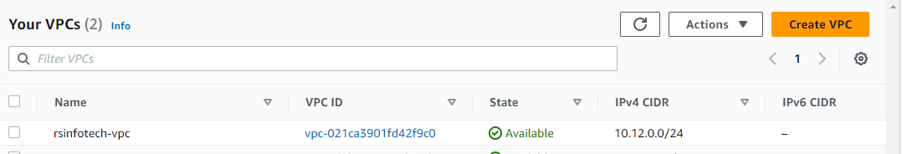

### -Create security group:

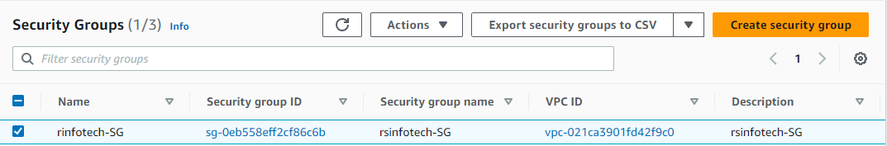

### -Create public subnet:

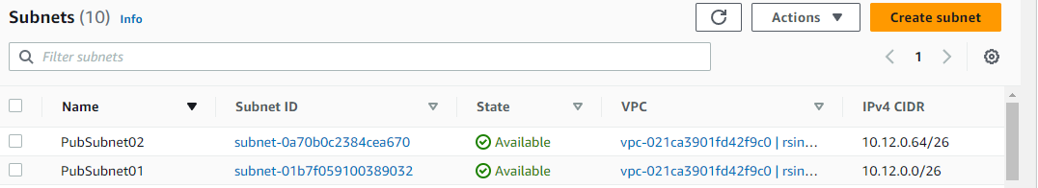

### -Create Internet gateways and attach to VPC:

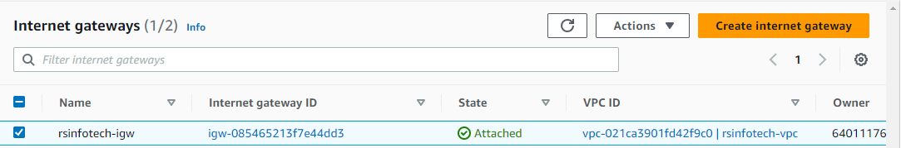

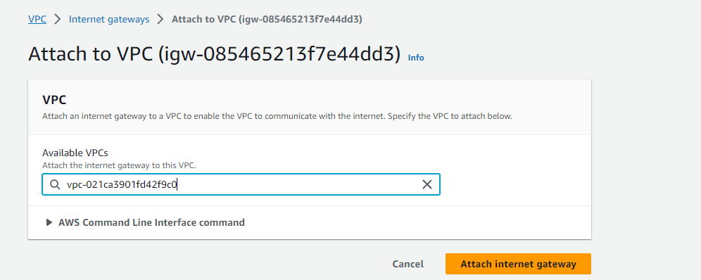

### -Create Route Table and publicsubnet associate with public route table

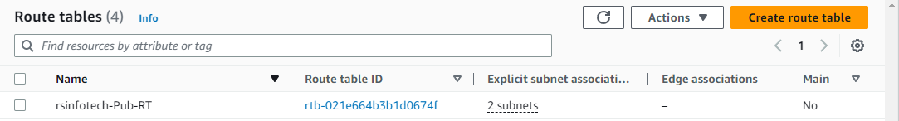

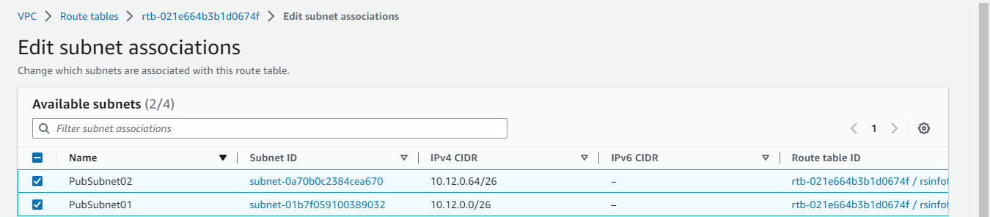

### -Create EC2 instance (Redhat server):

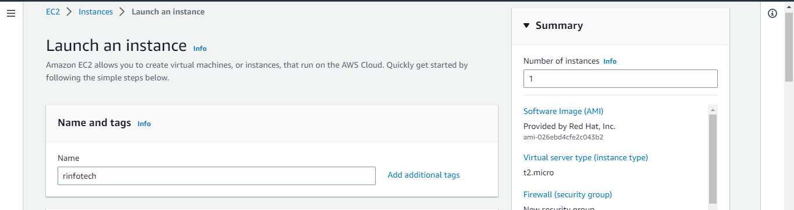

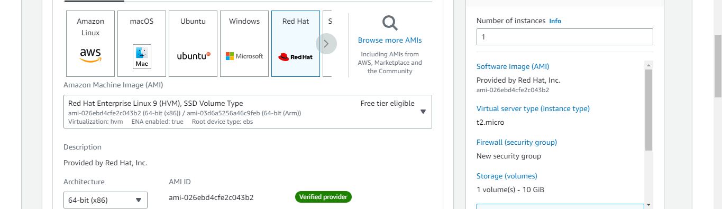

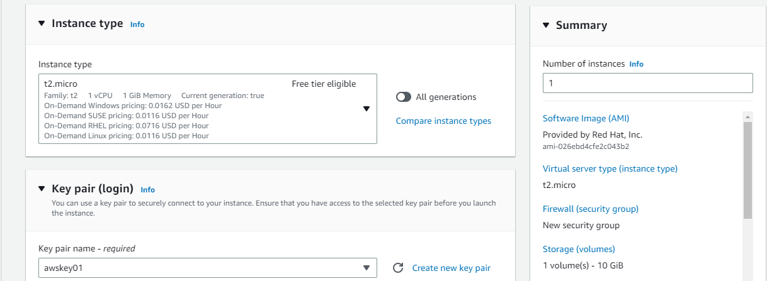

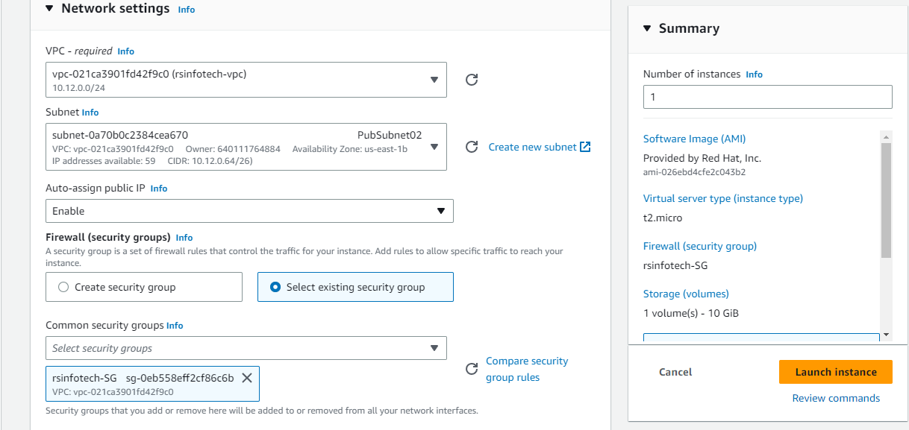

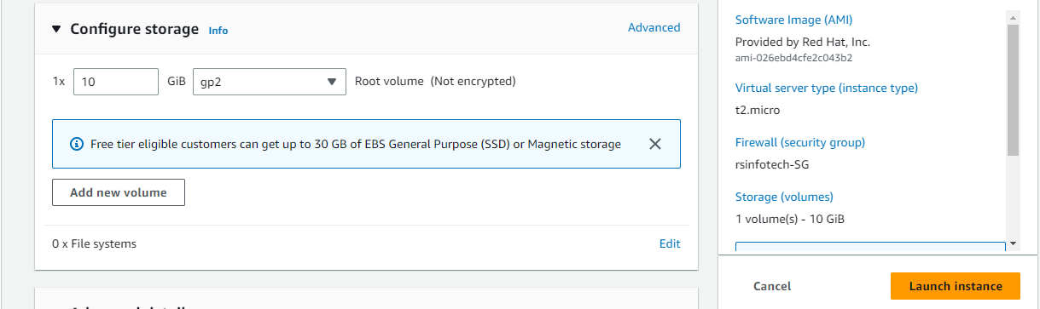

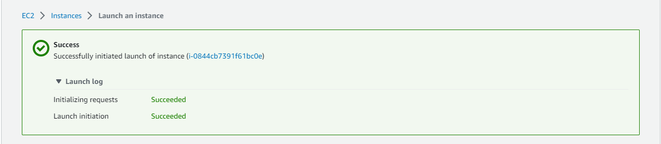

### -Successfully created Instance:

## 

## **Connect to EC2 instance using putty software:**

### **-**Putty configuration:

Putty Settings:-

Connection ---->Data: Auto login

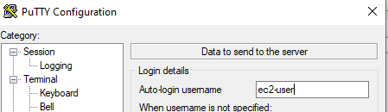

Windows-->: Control the scroll back

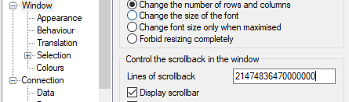

SSH--->Auth: Credentials: public key: Browse..

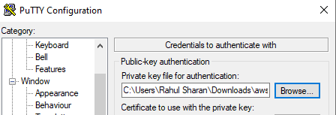

Session--->Hostname or IP: public IP and Port--saved session—load—open—Accept.

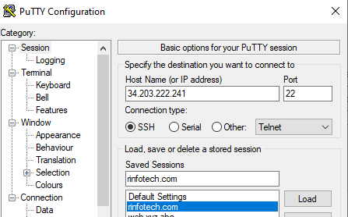

Connection: Second between keepalives

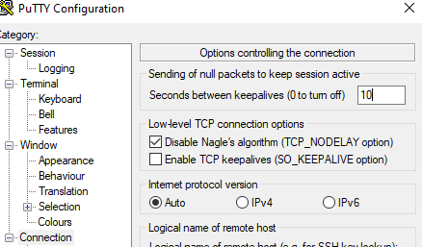

### -Successfully connected Instance:

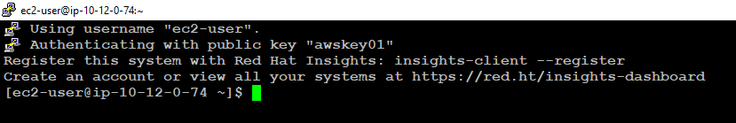

## **To configure the Apache webserver using the EC2 instance:**

### -Install the apache package and updates using the following commands:

$sudo su –

#yum install update –y

#yum install httpd –y

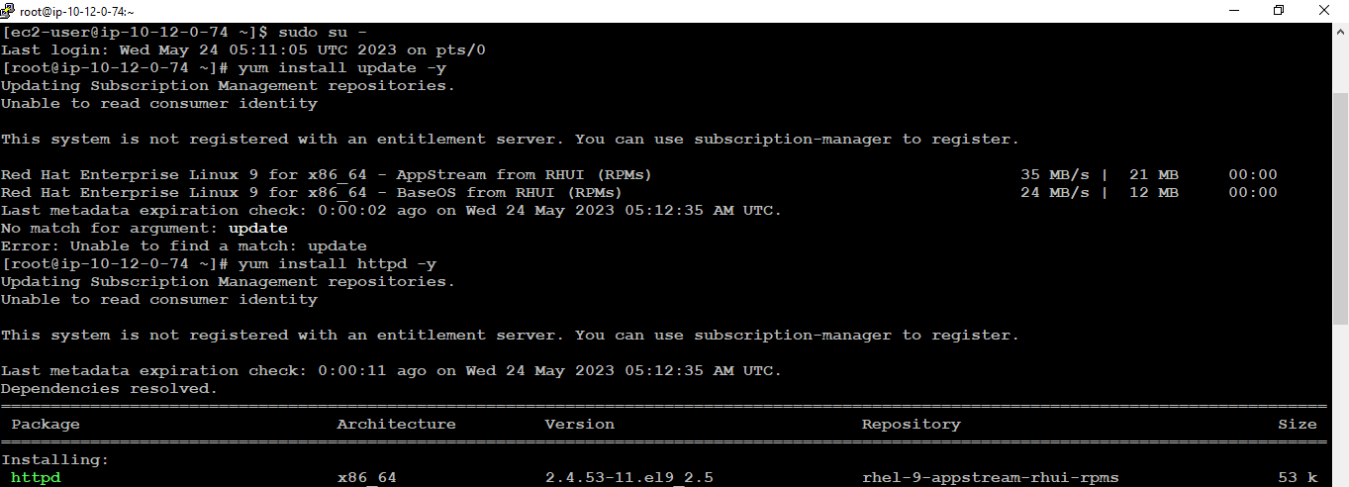

### -To check and start the apache service using the following commands:

#systemctl status httpd

#systemctl start httpd

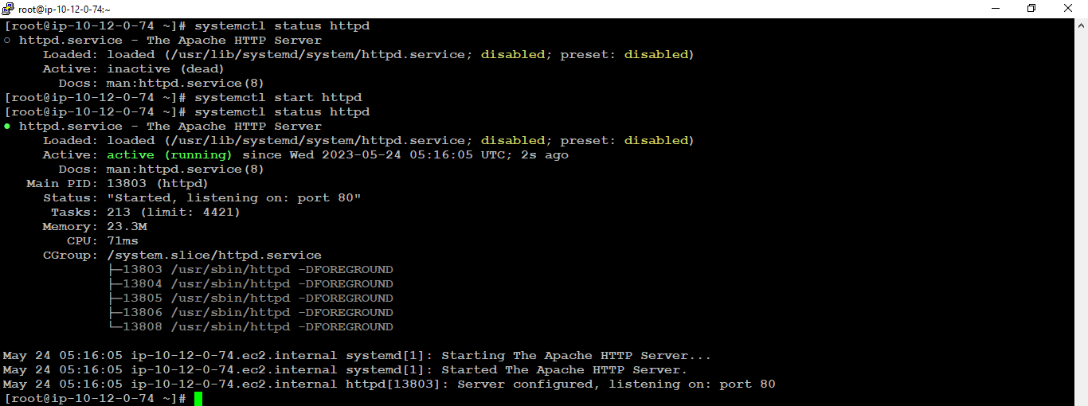

### -Configure the document root of apache using the following path:

#cd /var/www/html/

#ls –ltr

#vim index.html

Insert: Paste the .html file and save using esc: wq!

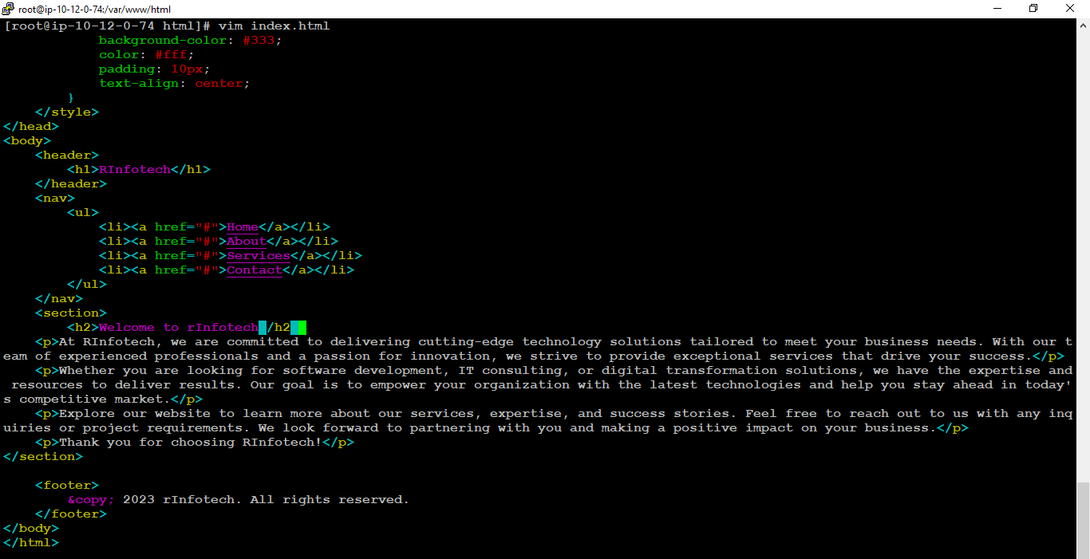

### -Change the index.html file owner as an apache using the following command:

#ls –ltr

#chown -R apache index.html

#ls –ltr

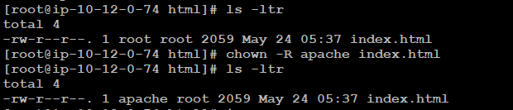

### -Local DNS configuration on physical machine windows_10 using the following path:

C:\Windows\System32\Drivers\etc\hosts



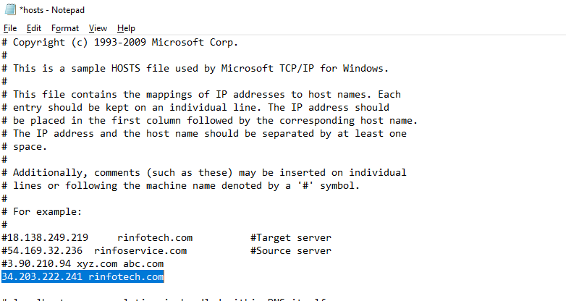

## **To validate the website using Google chrome web browser:**

### -Open the web-browser and type the rinfotech.com

